**User Interface Design:**

**User Interface-> Section Rule**

**Understanding Section Rule:**

**Section is an instance of Rule-Html-Section**

**Section Contains  Layouts( Tables) & Controls ( UI Elements)**

**Req: Working with Section Rule: Create a New Section for collecting Customer Details:**

**Create a Section from User Interface Category:**

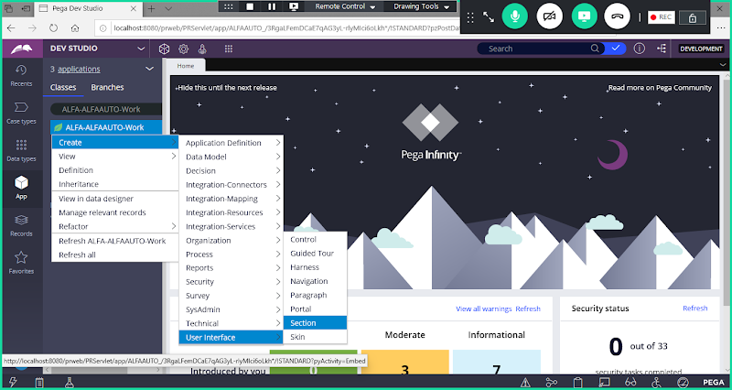

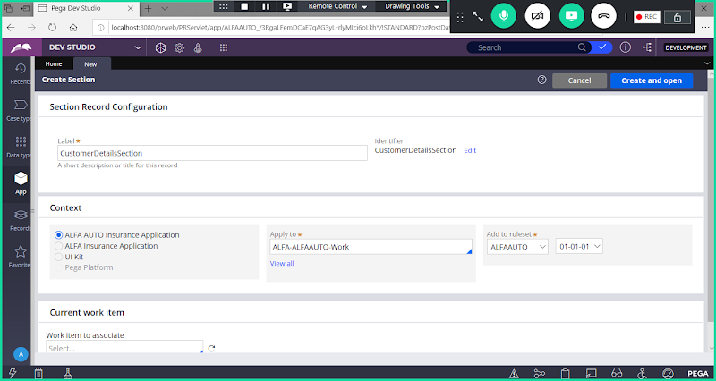

**Open**

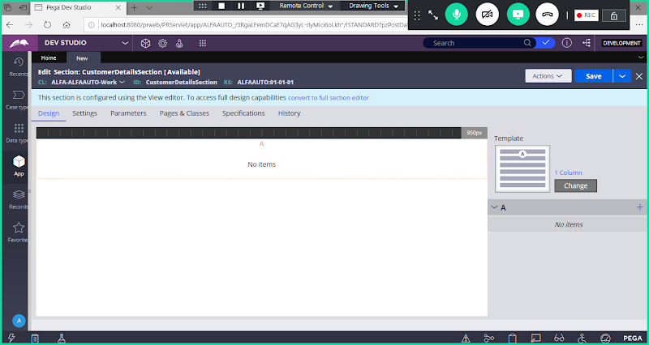

**Now Covert to Full Section Editor**

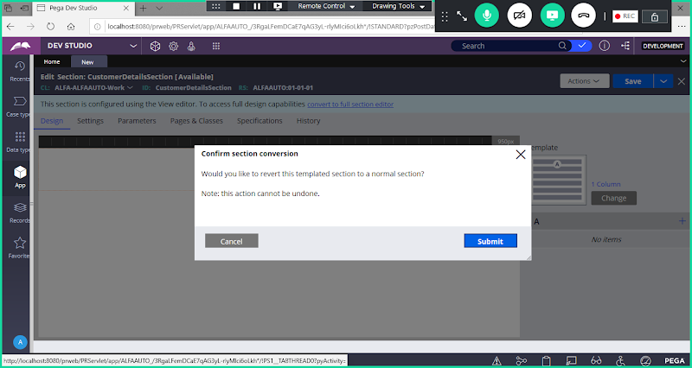

**Click on Submit**

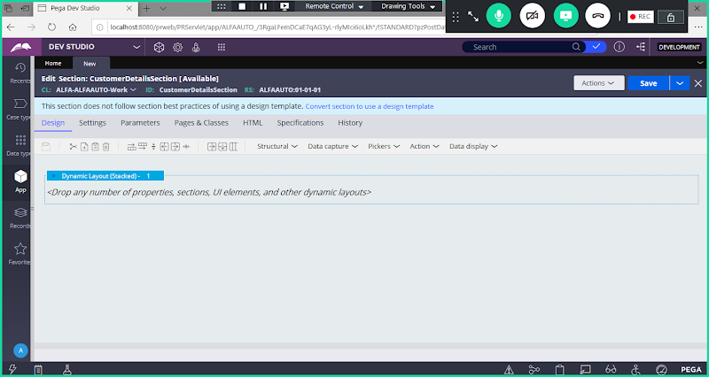

**Dynamic Layout(Stacked)**

**In Layout: We can add Properties, Sections, UI Elements, Other Dynamic Layout**

**How To Change the Layout Format:**

**Change the layout format:( Double click on Layout settings)**

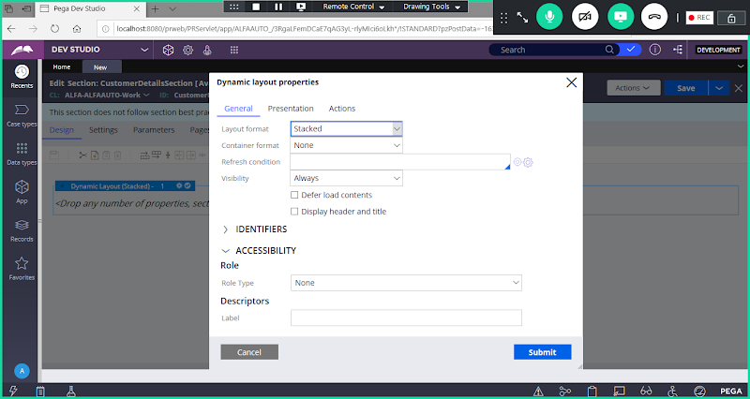

**Under Layout Format: Inline Grid Double**

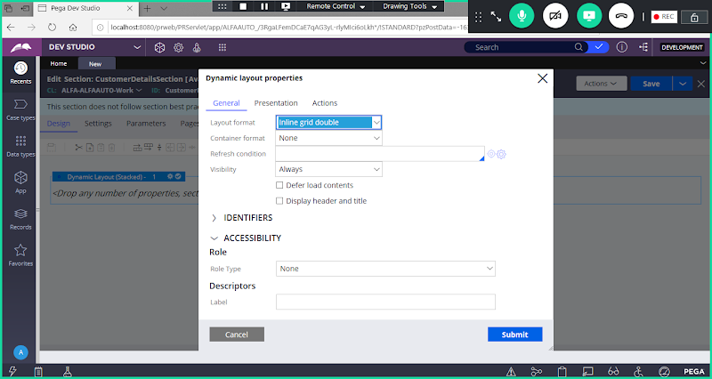

**Now Add Header & Title for the Page: ( Select Check Box - > Display Header & Title)**

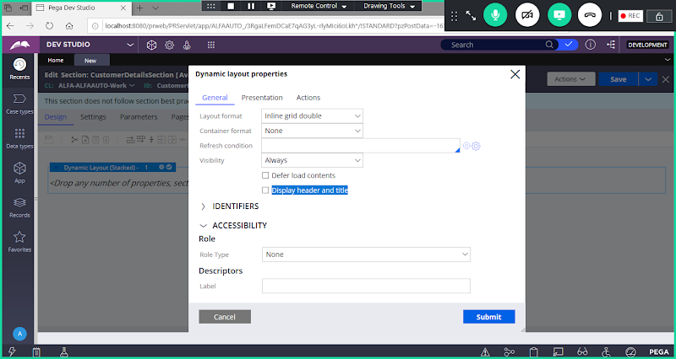

**Enable Check Box**

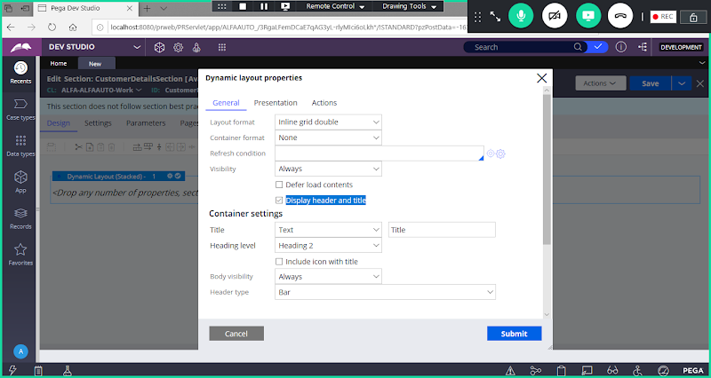

**Add New Title**

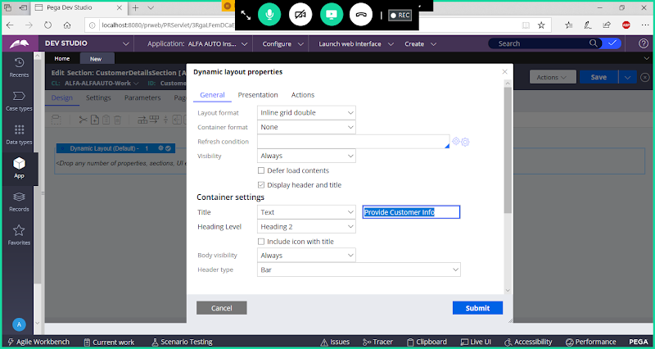

**Submit**

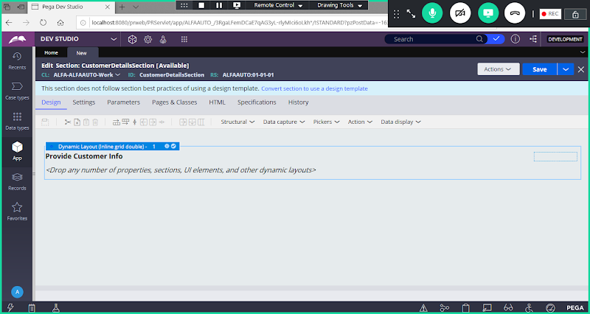

**Now Add Dynamic Layout inside Layout 1: i.e Inside Layout 1, we will add Layout 1.1**

**From Structural Drop down, Drag & Drop Dynamic Layout inside Dynamic Layout1**

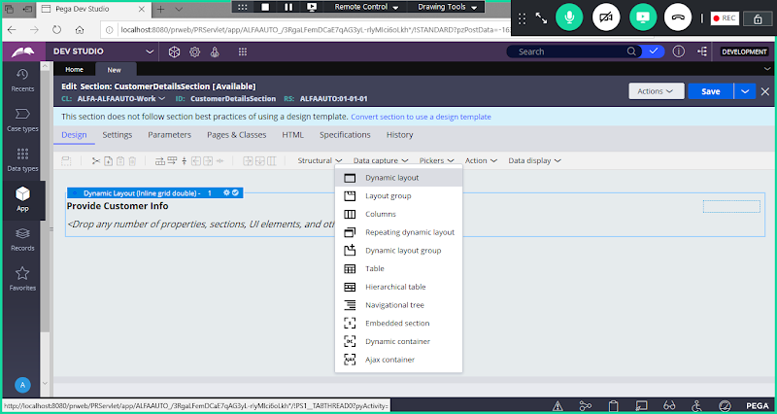

**Drag & Drop inside Layout 1**

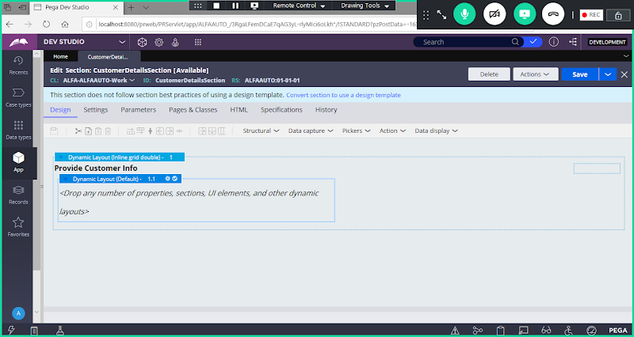

**Now Set Layout format for 1.1. Double click on Layout 1.1**

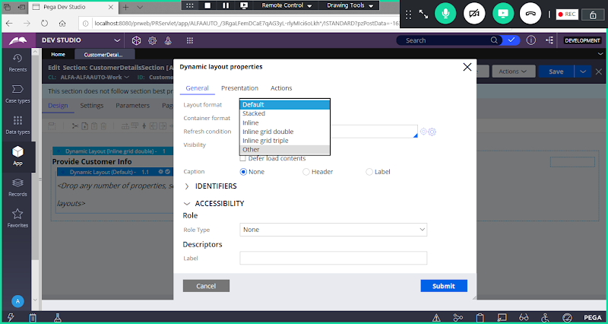

**Under Layout Format Select Other:**

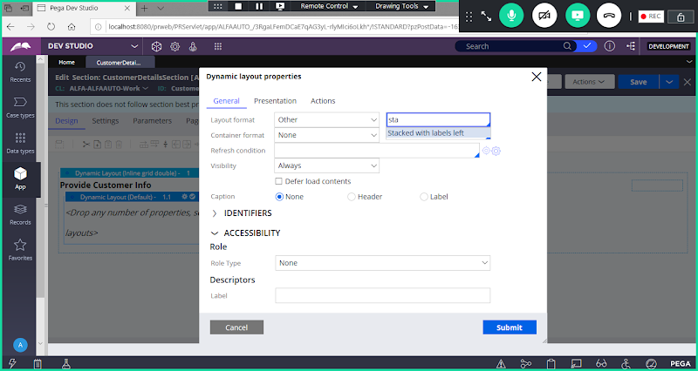

**In Drop down Select: Stacked with labels Left**

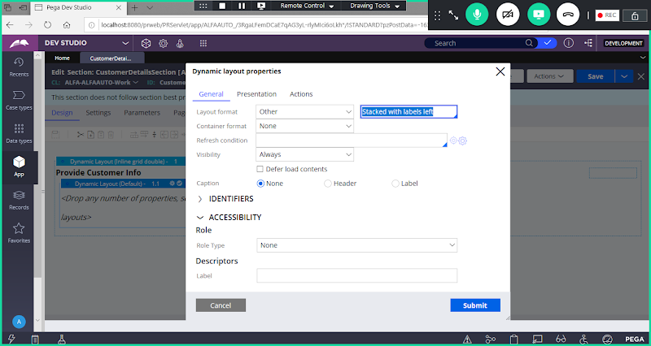

**Submit**

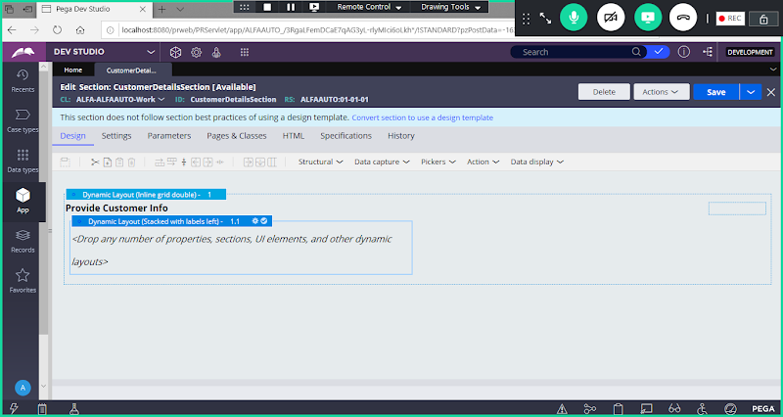

**Add Properties under Dynamic Layout 1.1**

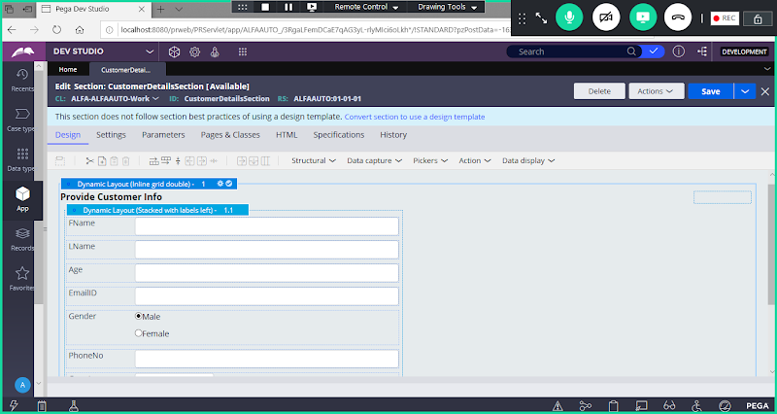

**Save Section**

**How to Change Property Control @ Section Rule:**

**Change Country Property Control to AutoComplete.**

**Double Click on Country Field:**

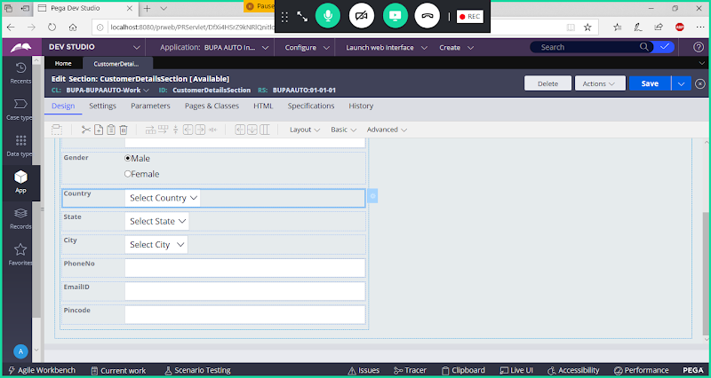

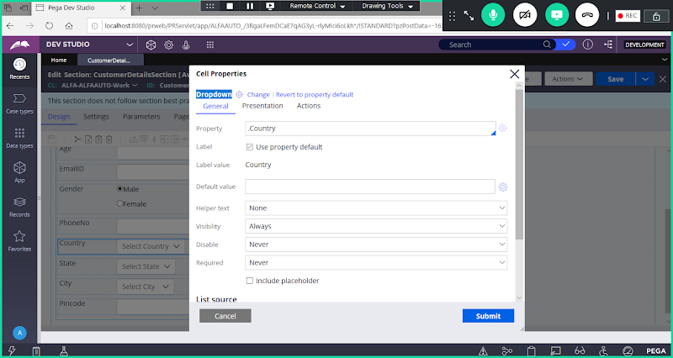

**Click On Change**

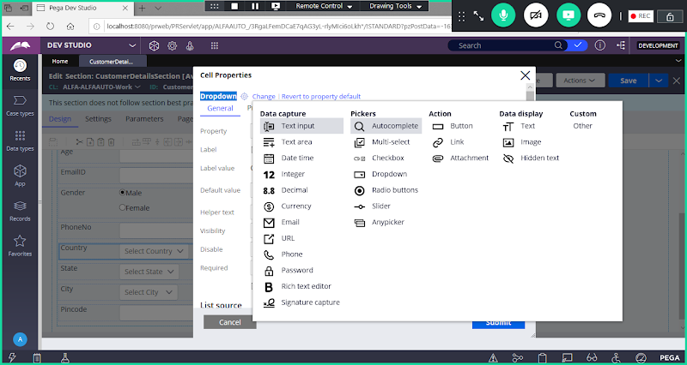

**Under Pickers Select AutoComplete**

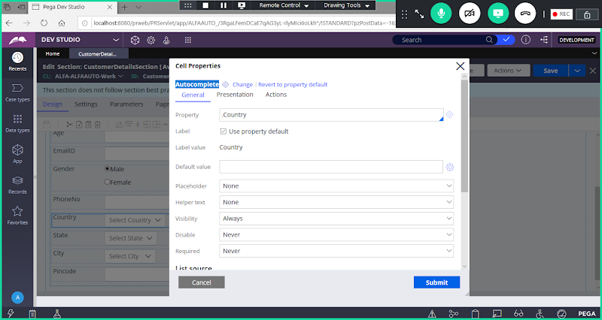

**Click on Submit**

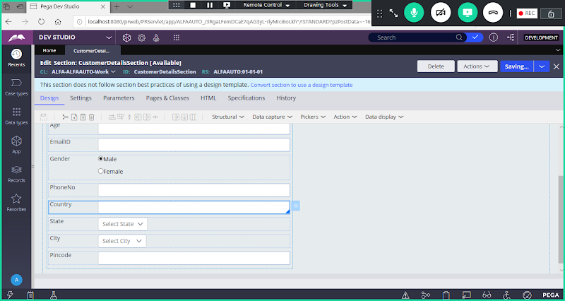

**Save Section.**

**How to Update Property Label:**

**Update Label for FName & LName Properties:**

**Double Click on FName**

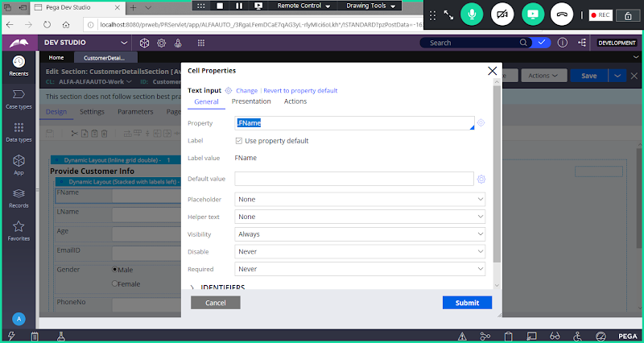

**Now Disable Use Property Default Check box**

**Change Change Label Value: First Name**

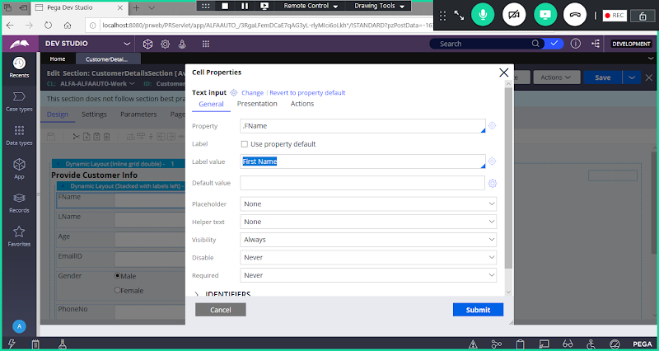

**Submit**

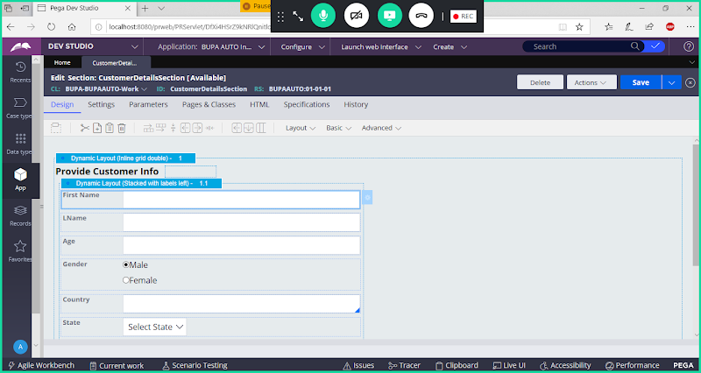

**Save Section**

**Similarly Update Label for LName to Last Name**

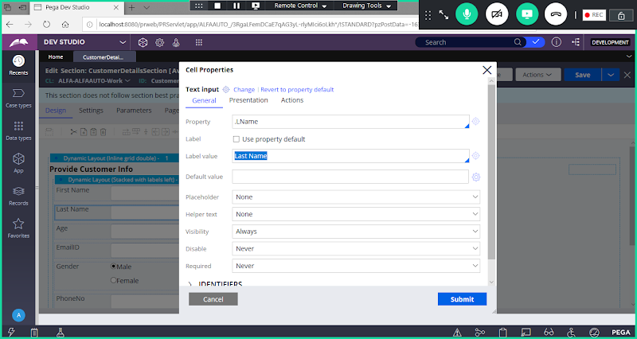

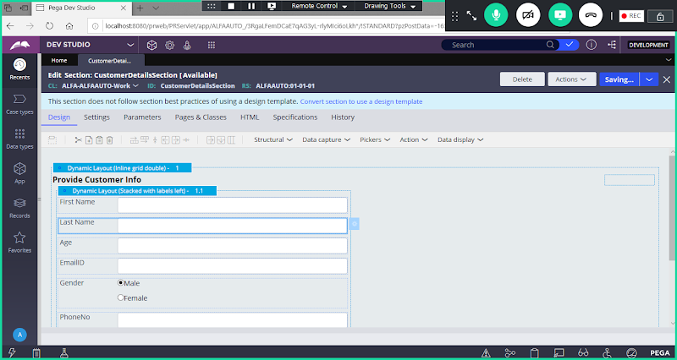

**Save**

**How to Set Field As a Required Filed:**

**Ex:  FName**

**Double click on FName Property**

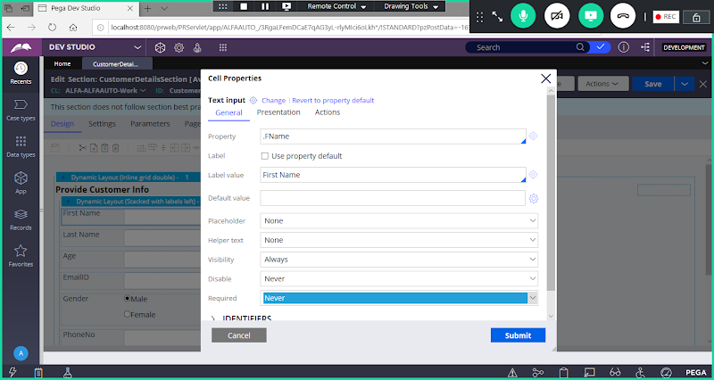

**Under Required Select: Always**

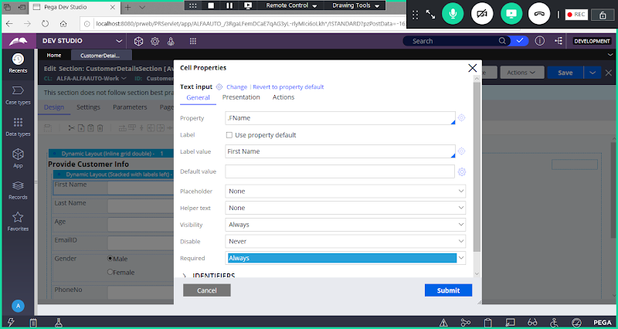

**Submit**

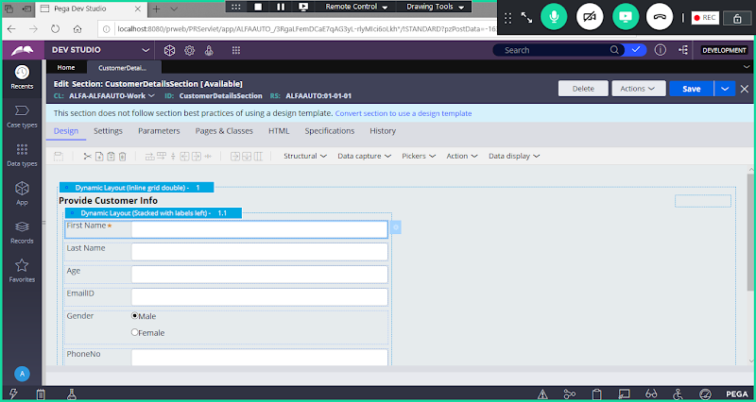

**Save Section**

**How to Change Text Alignment:**

**By default for Text /Phone/Email/Dropdown/Radio Button Types (  Text Alignment will be Left side)**

**By Default Integer Type ( Text Alignment will be Right Side)**

**Change Alignment to Left side for Age ( Interger)**

**Double click on Age Property**

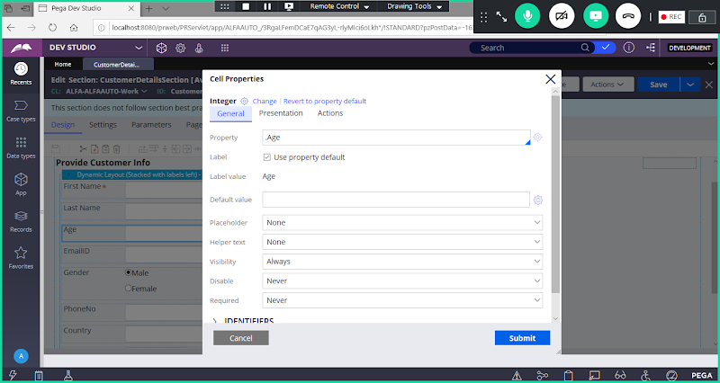

**Go to Presentation Tab**

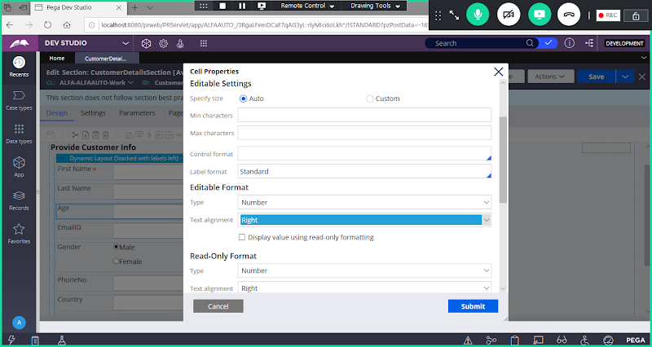

**Change Alignment to Left**

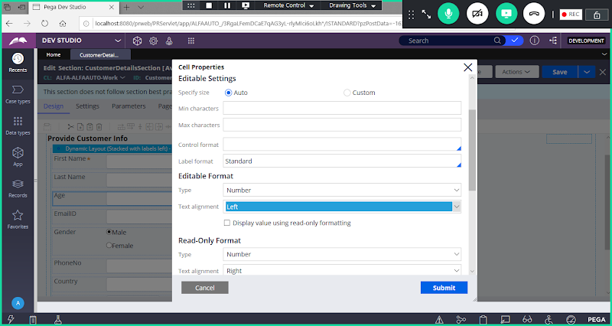

**Submit**

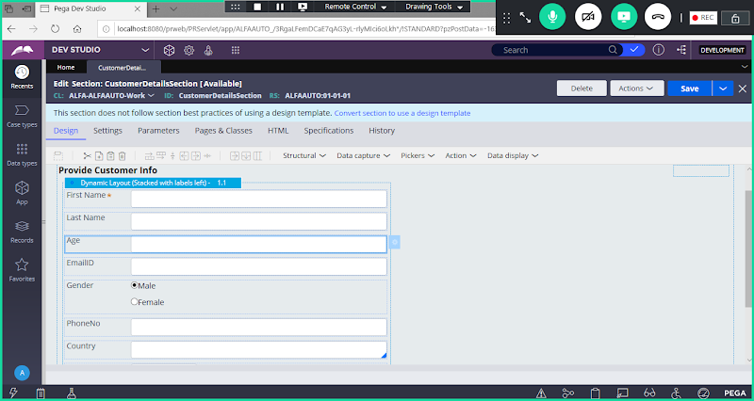

**Save Section**

==